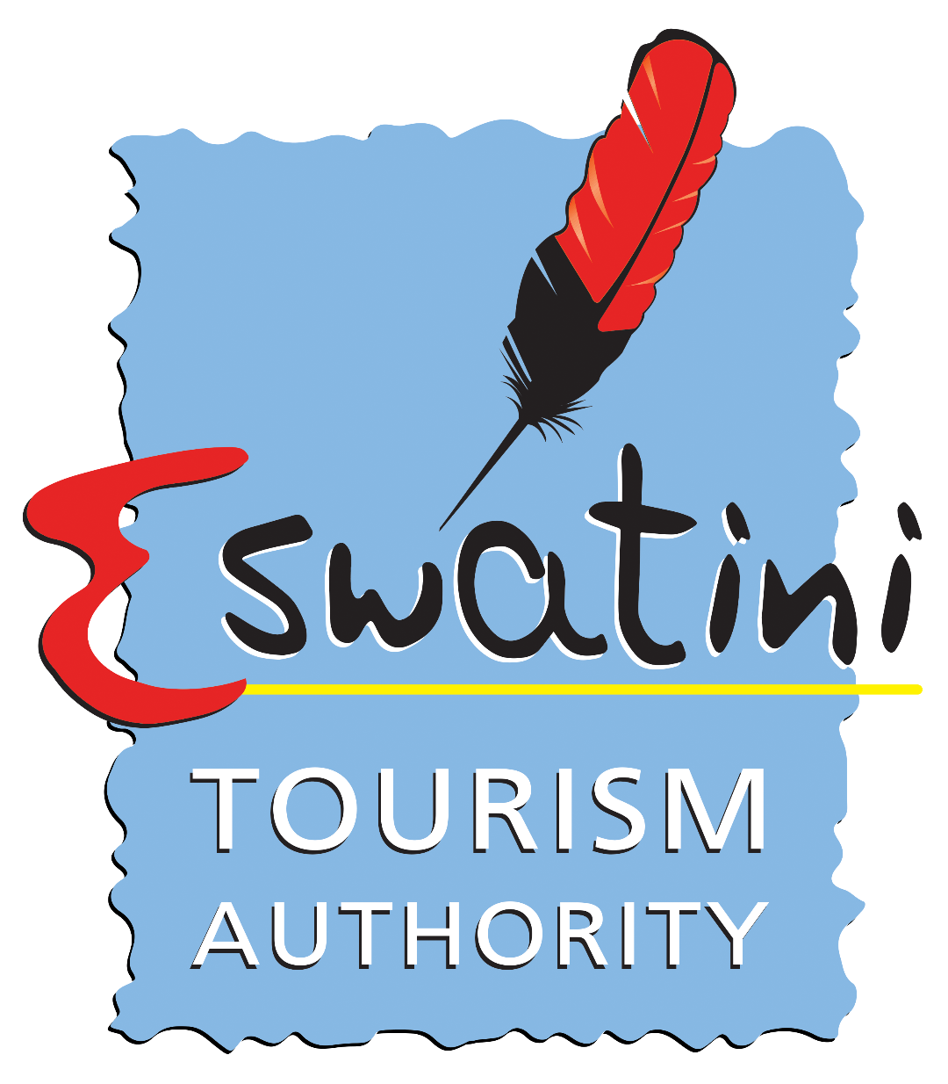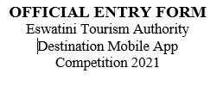

- Are you male or female? Tick ✔ the appropriate answer
Male Female
- Have you attached a certified copy of a national identification card? Tick ✔ the appropriate answer
Yes No
- Do you have a website development skill? Tick ✔ the appropriate answer
Yes No
- Are you a businesswomen or businessman or an aspiring entrepreneur? Tick ✔ the appropriate answer
Have a business Aspiring entrepreneur

- Do you have a company? Tick ✔ the appropriate answer
Yes No
- If a company already exists, when was it registered ?____/ ____/ ______ (DD/MM/YYYY)

- Have you attached a Memorandum of Association and Form J? Tick ✔ the appropriate answer
Yes No

- All fields must be completed.

Title of innovation
……………………………………………………………………………………………………………………
Brief description

- Technical skills and entrepreneurial behavior of person(s)

Name | Current Occupation | Name of Company / Employer | Key deliverables todate | List of apps developed or portfolio related to apps

- Description of activities, time periods and technical specification related to the proposed mobile app.

- Business Proposal
Main product or service offering
Target Customers
Investment made into the business so far
Key business deliverables for next two years
Paste income projection for the next two years
Brief description of how an award could improve the business

- Acceptance of competition terms and conditions:

Signature: _____________________________

Date: ________________________________

For Office Use Only:

Received Date & Time:

Assigned Reference No.:

Signature of Attending Officer:

